India-U.S. Relations: A Comprehensive Study/Volume 1/Politos/December/2024/
Aman Kumar

INDIA-U.S. RELATIONS:
A COMPREHENSIVE STUDY

AUTHOR: AMAN KUMAR, SHAMBHU DAYAL (P.G.) COLLEGE,
GHAZIABAD

ABSTRACT

The India-US Relations has evolved significantly over the decades, transitioning from a period of mutual suspicion during the Cold War to a robust strategic partnership in 21st Century. This research paper explores the multiple dimensions of India-US Relation, focusing on key areas such as defense cooperation, economic ties, and geopolitical strategies. The paper involves a qualitative approach, providing data and comprehensive overview of the bilateral agreements and policy shifts. The findings suggest that while there are areas of contentions, the evolving trend towards a deepening partnership driven by shared democratic values and strategic imperatives. It also analyse the convergence and divergence of national interest. The study examines the historical context of bilateral relations, highighing pivotal moments that have shaped the current The research aims to contribute to understanding of how India-US navigate their complex relationship on the boat of their national interest.

India-U.S. Relations: A Comprehensive Study/Volume 1/Politos/December/2024/
Aman Kumar

INTRODUCTION

Former US President Barack Obama said,
“India and US have thrown off the yoke of colonialism and have drafted the constitutions that begins with the same three words: ‘We the people' “.
He symbolizes the pluralist nature of both states. The statement come in the purview of strategic relationship between both states covering almost every areas of human endeavor, driven by shared democratic values, convergence of interests on a range of issues and vibrant people to people contact.
The relationship between India and US has undergone significant transformation since India's independence in 1947. Initially marked by mutual suspicion during the Cold War, the bilateral ties have evolved into a comprehensive strategic partnership in 21st century. The United States supports India's emergence as a leading global power and a vital partner in promoting a peaceful, stable and prosperous Indo-Pacific region.
The Government of India placed emphasis on development and good governance created opportunity to renovate bilateral ties and enhance cooperation under the motto - "Chalein Saath Saath: Forward together We Go" and “Sanjha Prayas, Sab ka Vikas” (Shared Effort, Progress for All). Today, the India-US bilateral relation is broad-based and multisectoral, covering trade and investment, defense and security, technology, clean environment, agriculture and health. Vibrant people-to-people Connect and support across the political spectrum in both Countries murture our bilateral relationship.

HISTORICAL CONTEXT

India US relations have evolved since India's Independence in 1947 from divergence
India-U.S. Relations: A Comprehensive Study/Volume 1/Politos/December/2024/
Aman Kumar

to convergence. The early period of both states determined, majorly, by Cold War dynamics.
1. Early Post Independence Period (1947-1960s)
PM Jawaharlal Nehru made India's foreign policy on the line of Non alignment. According to this, India maintained Strategic autonomy by not aligning with either the United States- led Western bloc or the Soviet-led Eastern bloc. This approach created some distance between India and the US, particularly as the US was keen to contain Soviet influence in South Asia. During this period, US relations with India were characterized by moments of cooperation such as the food aid (under the PL-480 program), but also significant divergences particularly over India's stance on the Korean War and its reluctance to align with US foreign policy.

2. Cold War and tilt towards the Soviet Union (1970s-80s)
The India-US relation diverged during the Cold War, initially following Indo-Pakistan War, 1971. In opposition, US tilted towards Pakistan for his key ally in South Asia during Cold War. This period saw India signed a Treaty of Friendship and Cooperation with the Soviet Union in 1971, which further made strong step towards Soviet Union-bloc.
India tested her first nuclear bomb in 1974 under Operation Smiling Buddha (Pokhran-I). In reaction, US imposed sanction on India which marked as low point in relationship between both states. Both states followed different priorties with the US focused on non-proliferation and India on securing its strategic autonomy.

3. Post-Cold War Period and Economic Engagement (1990s- present) India US relation turned after the end of cold war and disintegration of USSR in early 1990s. India adopted policy of economic liberalization in 1991, focusing on LPG reforms (Liberalization
India-U.S. Relations: A Comprehensive Study/Volume 1/Politos/December/2024/
Aman Kumar

Privatization and Globalization) which opened new avenues for bilateral engagement. Under Narsimha Rao primeministership, Indian economy began to reform itself to integrate more closely with the global economy creating new opportunity for trade and investment with US.
But once again, US imposed sanction on us by following 1998 nuclear test under Operation Shakti. These sanctions were lifted in the early 2000s as both countries realised the importance of strategic cooperation in changing global order.
The India-US Civil Nuclear Agreement, 2005 under President George W. Bush and India's PM Manmohan Singh marked a significant milestone in bilateral relationship, signalising a new era of strategic partnership.

STRATEGIC AND DEFENSE COOPERATION

The strategic and defense cooperation between India and USA has significantly deepened over the past two decades, reflecting shared interests in regional stability, counter-terrorism and a mutual commitment to a free and open Indo-Pacific. The Cooperation is characterised by regular institutionalised bilateral dialogue, military exercises and defense procurements. Mostly, the cooperation in strategic and defense seen by the lens of China. USA follows ‘China +1' strategy which provide opportunity to engage with India strategically.
India-US defense agreement for interaction and cooperation are
(i) LEMOA (Logistics Exchange Memorandum of Agreement) 2016. This agreement establishes the terms and conditions for the two militaries to share logistic support, supplies and services.
India-U.S. Relations: A Comprehensive Study/Volume 1/Politos/December/2024/
Aman Kumar

(ii) GSOMIA (General Security of Military Information Agreement) 2002- This agreement allows the militaries of both countries to share intelligence.
(iii) COMCASA (Communication Compatibility and Security Agreement) 2018- The agreement provides a legal framework for the transfer of sensitive communication security equipment from the US to India.
(iv) BECA (Basic Exchanges and cooperation Agreement for
Geospatial Intelligence) 2020- This agreement allows India and the US to share geospatial and satellite data including maps and nautical charts.
- New Framework For India-US Defense Cooperation(2015) defines
- maintaining security and stability
- defeating terrorism and violent religious extremism
- preventing the spread of weapons of mass destruction and
associated materials, data and technologies,
- protecting the free flow of commerce via land, air and sea lanes.
- India designated as "Major Defense Partner (MDP) of U.S. in 2016, which allows India-US engagement in close military Cooperation through joint training, exercises and collaborative efforts.
Joint Military exercises.-
-Yudh Abhyas (Army)
- Malabar (Navy)
- Tiger Triumph (tri-services)
- Vjra Prahar (special forces)
- Cape India (Air Force)
Multilateral exercises - Red Flag; RIMPAL; Sea Dragon;
CUTLASS Express and Milan.
India-U.S. Relations: A Comprehensive Study/Volume 1/Politos/December/2024/
Aman Kumar

- Defense procurements from US are growing and reached almost US $20 billion, making USA, a third largest exporter in defense (2023). Major defense of US-origin includes - C-130J, C-17, Apache, Chinook, MH6OR Helicopters and P8I.
- A defense innovation bridge - INDUS X (India-US Defense Acceleration Ecosystem) signed in 2023. It is a network of universities, incubators, corporaters, think tanks and private investment stakeholders to make defence ecosystem transparent, rapid and inclusive.
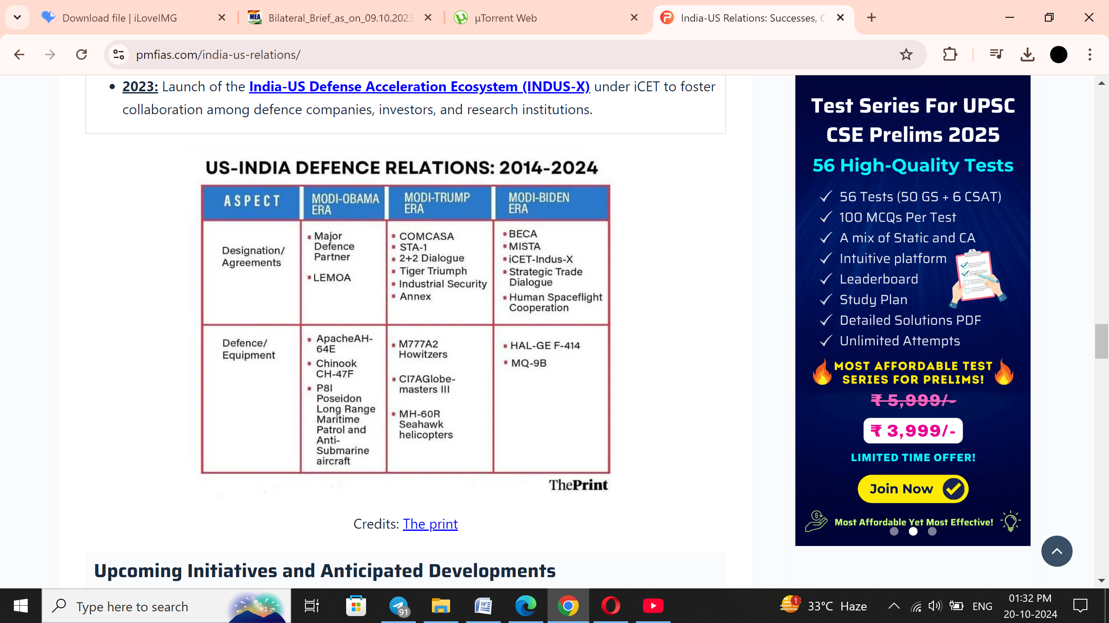
- In May 2023, the India-US Defense Industrial Cooperation Roadmap concluded to seek to fast-track technological cooperation and co-production in areas of mutual interest.

Strategic relationship between two nations has deepened, since
2014. There ‘Global Strategic Cooperation' based on shared democratic values and increasing convergence of interest on global issues. Both nations engage strategically in various forms, organisation and meeting. These are –
India-U.S. Relations: A Comprehensive Study/Volume 1/Politos/December/2024/
Aman Kumar

(i) Indo-Pacific Economic Framework (IPEF) 2022- It is an economic partnership launched by US and Indo- pacific region's Countries with the objective of resilence, sustainability, inclusiveness economic growth, fairness and competitiveness in the region. India has signed three pillars of the IPEF-committed to building more resilent supply chain; tapping clean energy opportunities; and combating corruption.
(ii) I2U2 - The group is a new strategic partnership formed between India, Israel, the United Arab Emirates, and the United States in 2021, to deal with issues concerning maritime security. I202 is focused on joint investments and new initiatives in water, energy, transportation, space, health and food security. The grouping will help emerge India as a global leader.
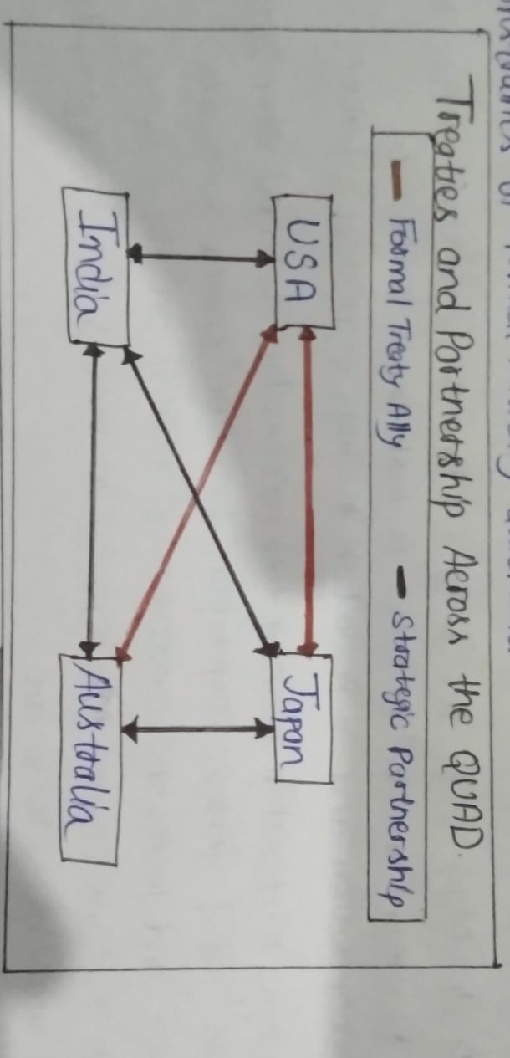
(iii) QUAD (Quadrilateral Security Dialogue) 2017- It is an informal strategic partnership between India, USA, Japan and Australia. It primary goal is to promote a free, open and prosperous Indo-Pacific region and countering China's growing influence in Indo-Pacific. The QUAD supports maritime security, infrastructure development and supply chain desilience. For India, the QUAD presents a unique opportunity to engage in regional cooperation with the US and its Asian allies without the constraints of formal military alliances.

India-U.S. Relations: A Comprehensive Study/Volume 1/Politos/December/2024/
Aman Kumar

ECONOMIC AND TRADE RELATION

The economic and trade relations between India and U.S. is robust and multifaceted, reflecting the deep ties between the two nations.

(1) Bilateral trade - In the fiscal year 2023, the bilateral trade between India - US reached a record $128.78 billion. India had a trade surplus of $28.30 billion with the US, with Indian exports to the US standing at $78.54 billion and US exports to India at $50.24 billion.
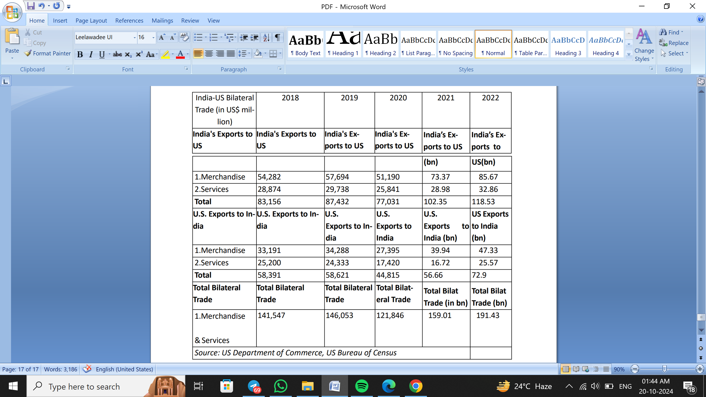
India US Bilateral trade data (2018-2022)

(ii) Major Exports and Imports.-
- India's Exports to U.S. : Key exports include gems and jewelry,

India-U.S. Relations: A Comprehensive Study/Volume 1/Politos/December/2024/
Aman Kumar

pharmaceutical products, petroleum products, engineering goods and apparel.
- US Exports to India - Major imports from the U.S. include
Petroleum (crude and products), pearls and precious stones,
Coal and machinery
(iii) Investment- The U.S. Is the third largest investor in India, with Foreign Direct Investment (FDI) inflows of $62.24 billion from April 2000 to September 2023. This investment spans various sectors, including technology, manufacturing, and services. Many U.S. tech firms have established Operations in India, benefitting from its skilled workforce and innovative ecosystem
(iv) Trade Agreements and Initiatives - Bilateral trade agreements initiated to address trade barriers and enhance cooperation in various sectors, including digital trade and agriculture.
The Trade Policy Forum Working Group on Resilient trade launched in 2023 (primer of Free trade agreement) is to discuss
trade and investment issues. The group is co-chaired by the Minister of Commerce and Industry for India and US Trade Representative. The group initiate -
- Facilitating trade and investment flows between two countries
- Developing and implementing trade policies.
- Capacity building on Intellectual Property Rights (IPRA)
In G-20 Leader's Summit, PM Narendra Modi and US President Joe Biden (2023) meet to accelerate investment in high-quality infrastructure projects and development of 2-economic corridors-
- India Middle East Europe Economic Connectivity Corridor.
- Partnership for Global infrastructure and Investment.
(v) Bilateral engagements are made for growth in areas like renewable energy health care,
India-U.S. Relations: A Comprehensive Study/Volume 1/Politos/December/2024/
Aman Kumar

digital sector, cyber security and data protection. MoUs signed on critical minerals which
expands collaboration in trade and critical emerging sector.
TECHNOLOGY AND ENERGY COOPERATION

In 2016, PM Modi declares in US Congress that India and US have overcome the “hesitation of history". Six years later (2022), "the hesitation of history" had developed into the Initiative for Critical and Emerging Technology (iCET). This emphasis the engagement of both nations towards innovation, sustainability and mutual growth to combat climate change and energy security.
(i) Clean Energy and Climate Change - Both countries are committed to advancing clean energy technologies and addressing climate change. They collaborate through initiatives like India-us Strategic Clean Energy Partnership (SCEP) 2021, which aims to enhance energy security, expand energy access, and promote clean energy innovation.
(ii) Technology Transfer and innovation - The U.S. and India work together to facilitate technology transfer and innovation in the energy sector. This includes cooperation on advanced technologies like hydrogen energy, battery storage, and Carbon capture and storage (CCSU) utilisation.
(iii) Research and Development - The partnership includes joint research and development projects in areas such as renewable energy, energy efficiency and smart grid technologies. This collaboration helps in sharing best practices and developing new technologies to reduce carbon emissions.
(iv) Investment in Clean Energy - Both nations are investing significantly in clean energy projects. The US has supported India's renewable energy goals through financial and technical assistance, helping India to become one of the largest renewable energy market in world.
India-U.S. Relations: A Comprehensive Study/Volume 1/Politos/December/2024/
Aman Kumar

(v) International collaboration - India –U.S. participate in global initiatives such as International Solar Alliance (ISA) and Mission Innovation which aim to accelerate the development and deployment of clean Energy technologies world wide.
Some initiatives taken up by India-US to make technology and energy trade, and collaboration more efficient are
- Coalition for Disaster Relief Infrastructure (CDRI) 2019 to promote the resilence of infrastructure system to climate and disaster risks, ensure sustainable development.
- Renewable Energy Technology Action Platform (RETAP) 2023- launched by India-U.S. to enable lab-to-lab collaboration, pilot projects, texting of innovative technologies and Capacity development.
The collaboration between India-U.S. is marked by a commitment to innovation, sustainability and security. Both nations seek to address global challenges like climate change and energy access benefitting both economies and their strategic partnership.

DIALOGUE MECHANISM

Dialogue mechanisms are crucial for advancing strategic Partnership and engaging diplomatically to pursue national interest. India and U.S. engaged in key dialogue mechanisms. They are-
(1) India-US CEO Forum (2005) - It is a platform that Convenes leaders of US and Indian business communities to develop and provide joint recommendations to strengthen bilateral commercial ties. It promotes effective dialogue mechanism across key sectoral theme to identify areas for Closer collaboration for mutual benefit.
(2) India-US Trade Policy Forum (TPF) (2005) - The objective of the forum are:

India-U.S. Relations: A Comprehensive Study/Volume 1/Politos/December/2024/
Aman Kumar

• Facilitate trade and investment; and foster conducive environment for
technological collaboration and innovation.
• Develop and implement trade policies through transparent
procedure that comply with international obligations.
The 13th Trade Policy Forum was held in Washington D.C. in 2023
(3) India- US Commercial Dialogue -The 5th Commercial Dialogue was held in New Delhi on March 2023. It focuses on cooperation in standards, ease of doing business, travel & tourism and other important issues of commercial significance. It is co-chaired by Minister of Commerce and Industry for India and US Secretary of Commerce.
(4) Indo-US Economic and Financial Partnership Dialogue (EPF)
2005- It is broad based dialogue mechanism covering areas. such as trade, investment, defense, science and technology and health. The dialogue led by India's Finance minister and U.S. Secretary of Treasury. The 9th EPF dialogue held in New Delhi, 2022.

(5) Indo-Pacific Economic Framework (2022) - The framework led by US aims to strengthen economic partnership among Participating countries to enhance resilience, sustainability, inclusiveness, economic growth, fairness and competition in Indo-Pacific region.
(6) India- Us Counter terrorism Cooperation - The cooperation partners to prevent terrorist attacks and bring to justice who Commit them. Regular meetings are held to share intelligence, Strategies and best practices in combating terrorism and enhancing security.
(7) Diaspora (People-to People Contact) - The Indian Diaspora is one of the largest in the world, with an estimated 18 million people living abroad. In USA, about 4.4 million Indian origin people reside which constitute the third largest ethnic group in U.S.A.
India-U.S. Relations: A Comprehensive Study/Volume 1/Politos/December/2024/
Aman Kumar

Indian diaspora considered as most influential group in U.S. that have played key role in transforming the relations. For example, the U.S. signing the Civil Nuclear Deal, 2005. Many American Indians have entered into the administration and the US Congress (currently five persons of Indian origin).

CHALLENGES AND CONTROVERSIES

- Different Stand on Various Geopolitical Issues: In early 2022, India’s neutrality on Russia’s aggression against Ukraine—and India’s abstention on all U.N. votes condemning or criticizing that invasion—met with dismay among some Members of the US Congress..
  - Oil Procurement from Russia: India’s increasing procurement of discounted crude oil from Russia has raised questions about the contradiction between India’s partnership with the US and its reliance on Russian oil.
- Strategic Convergence, the China Challenge: While India–US partnership involves broader and deeper issues, one of the predominant, shared concerns is China’s increasingly aggressive behavior, in particular along the disputed China—India border. These challenges are often addressed through ongoing dialogue and Cooperation, reflecting the resilience and depth of India-US. Partnership.
- Trade Protectionism: The US is concerned about India’s turn towards protectionism. For example, India makes up only two percent of the United States’ merchandise trade due to policies that protect domestic industry from foreign competition.
Trade issues include visa delays and revoking India’s trade benefits under the Generalized System of Preferences (GSP) program in 2019.

India-U.S. Relations: A Comprehensive Study/Volume 1/Politos/December/2024/
Aman Kumar

- The US has raised concerns about India’s protectionist trade policy and the existence of entry barriers for foreign investment.
- Data Privacy Concerns: Differing approaches to data protection and cross-border data. The U.S. seeks free data flow, while India emphasizes data localization for privacy
- Visa Restrictions: Stricter U.S. visa regulations, particularly for H1-B visas, limit Indian IT professionals’ mobility and affect the tech industry

FUTURE PROSPECTS:

"India's relationship with the U.S. has been the most comprehensive association the country has had since independence…....this is truly a relationship forged in crisis" written by Rudra Chaudhuri (head of Carnegie India) in his book Forged in Crisis: India and the US since 1947.
The statement marked India-US relationship as promising, driven by mutual interests and shared goal. Several key areas that suggest potential for future growth and collaboration are-
- Economic growth and Trade - Increase trade by reducing barrier. Sectors such as agriculture, technology and services will be focal point.
U.S. investments in Indian startups and infrastructure are expected to grow, while India continue to invest in U.S. technology.
- Strategic and Defense ties - Promotion of defense cooperation agreements will deepen, focusing on joint exercises, arm sales and technology sharing.
The partnership will continue to play a crucial role in maintaining Stability in Indo-Pacific region to counter China's influence.
India-U.S. Relations: A Comprehensive Study/Volume 1/Politos/December/2024/
Aman Kumar

- Technological innovation - Cooperation in technology, cyber-security and digital trade will strengthen on innovation and addressing challenges like data protection.
Collaboration in Research & Development particularly in areas like artificial intelligence, biotechnology and space exploration will foster mutual growth.
- Diaspora Connection - There will enhancing cultural tres, education and research partnership that foster understanding and collaboration between citizens.
The Indian-American community will play a vital role in strengthening ties, acting as a bridge in various sectors, including business and academia.
The India-U.S. relationship poised for future growth and deepening collaboration across multiple sectors. By addressing challenges contructively and leveraging shared interests, both countries can enhance their partnership and contribute to global security and stability.

CONCLUSION:
The India-US relationship is marked by a dynamic partnership with significant potential for growth across various domains. As Dr. S. Jai Shankar, External Affairs Minister said,
"Just as the book acknowledges, the relationship with the U.S. is for strategic and economic purposes a ‘very invaluable relationship for us' “
The relationship between both nations navigate complex global challenges, their collaboration in economic, defense, technology and climate sectors stands to enhance regional stability. The emphasis on innovation and sustainable development will further allign with objectives, fostering a relationship to global stability and prosperity. Overall, the future of India- US relations holds promise, doiven by shared values and a commitment to problem-solving.

India-U.S. Relations: A Comprehensive Study/Volume 1/Politos/December/2024/
Aman Kumar

BIBLIOGRAPHY:

Books:
- Chaudhuri, Rudra (2014), "Forged in crisis: India and United States since 1947” New York: Oxford University Press.
News Articles:
- Roy, Shubhajit (2023), "India-US ties: Trust & Necessity",
The Indian Express.
- Sasi, Anil (2023), India-US Trade & Strategy," The Indian
express
Government Reports:
- Indian Ministry of External Affairs (2023)" Annual Report on India-US Relations" 132-137, retrieved from mea.gov.in.
- Indian Ministry of External Affairs (2023)" Bilateral Brief of India-US Relations."
Online resources:
- Council on Foreign Relation, "US India Relation: 1947-2023" Retrieved from CFR.org.
- Congressional Research Services (CRS) (2021), "India-US Relation” retrieved from cosreports.congress.gov.

